Title

**Installation of Genesys and proxy setting for magma**

**Prepared By**

**Helpdesk**

Date: Monday, 08-10- 2018

Version 2.0

**Document History**

|  |  |  |  |
| --- | --- | --- | --- |
| Date | Author | Revision | Description |
| 26-10-2010 | Team Lead Helpdesk | 1.0 | Document Creation |
| 08-10-2018 | Team Lead Helpdesk | 2.0 | Company Name changed from TBSS to CBSL |

|  |  |  |
| --- | --- | --- |
| Approved By: | Conneqt Business Solutions Limited | |
| Manager-Technology | 2.0 |  |

|  |  |  |  |
| --- | --- | --- | --- |
| **Distribution List** | | | |
| Name | Department | Company | Rights |
| Manager-IT Support | Technology | CBSL | Review & Comment |
| Manager-Technology | Technology | CBSL | Modify |
| AVP Technology | Technology | CBSL | Review & Approve |

Security Classification: CBSLRestricted.

* **Genesys installation**

**\\10.101.8.106\d$\Genesys Apps\genesys 8.5.112**

**Require version: 8.5.112**

**Setup :- For workspace**

**Run setup file**

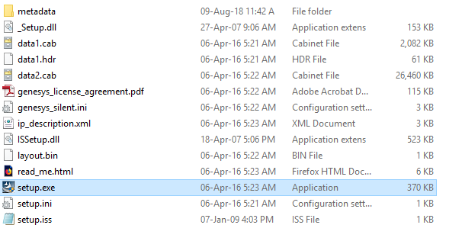 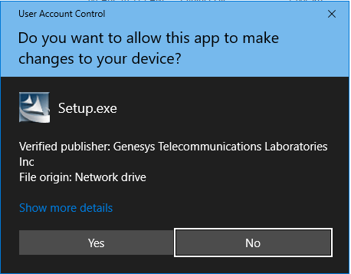 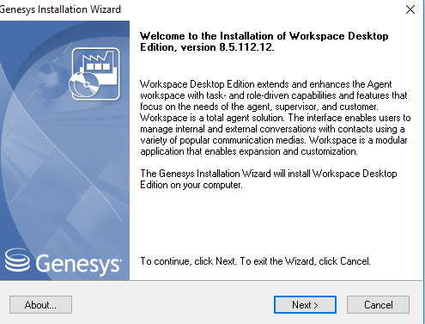

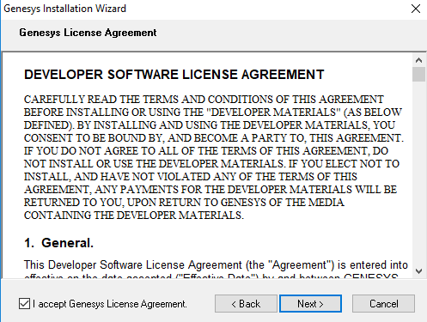

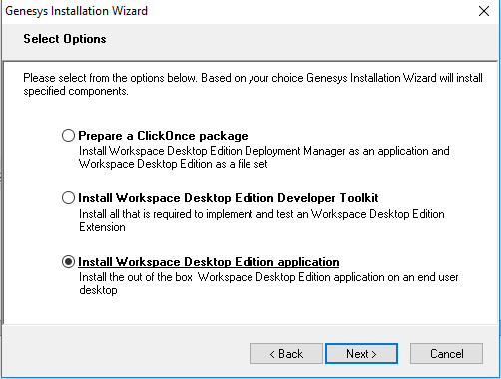

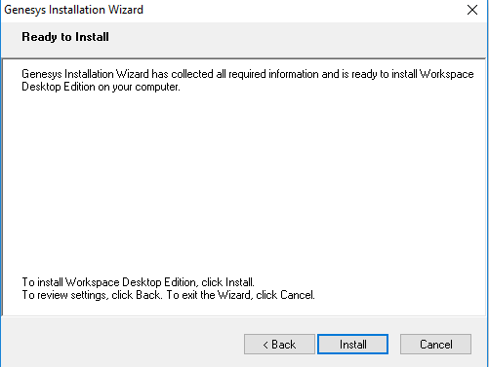

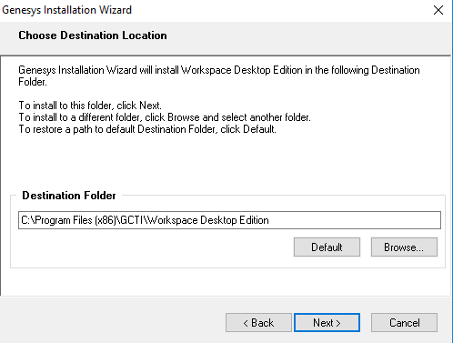

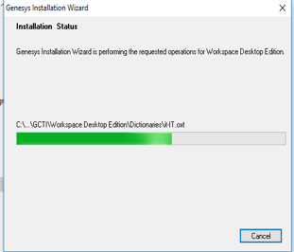

**Setup:- setup For SIP**



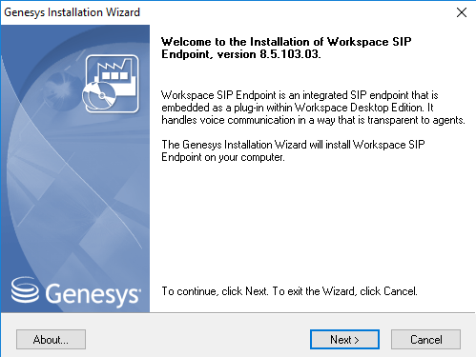

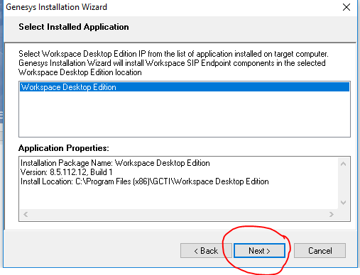

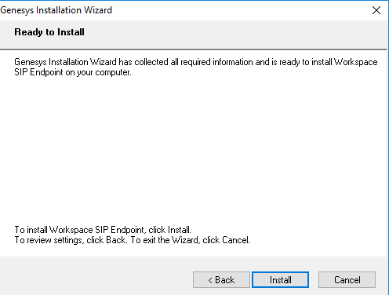

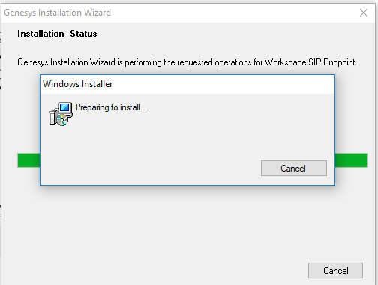

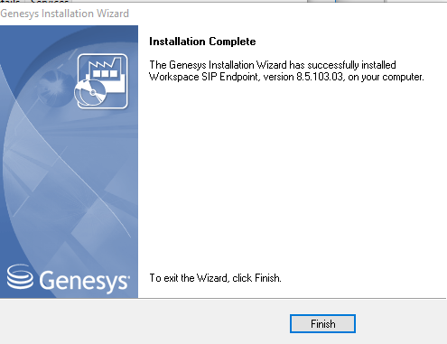

**Done.**

**For DLL file:**

**Need to put the DLL folder on below path**

**C:\Program Files (x86)\GCTI\Workspace Desktop Edition**

**For Proxy setting:**

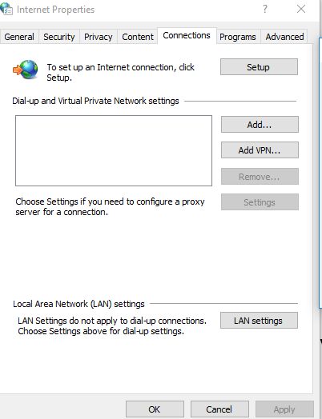

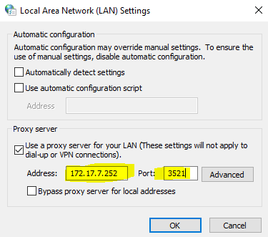

**Or**

**Need to paste proxy script on common startup below re the path details.**

**C:\ProgramData\Microsoft\Windows\Start Menu\Programs\StartUp**